

SECP1513 - 04
TECHNOLOGY & INFORMATION SYSTEM

PROJECT:
DIGITAL HEALTHCARE AND APPOINTMENT SYSTEM FOR UTM STUDENTS

LECTURER :
DR. SHAFAATUNNUR BINTI HASAN

GROUP 1
GROUP MEMBERS:
NAME | MATRIC NO
LIM JIA AN | A22EE0110
NUR ZAFREEN DAANIA BINTI MOHD WAZEER | A25CS0322
FATIN HUMAIRAH BINTI NORHISHAM | A25CS0061
CHE NURDIANA FARAHANA BINTI CHE REZALI | A25CS0201

VIDEO PRESENTATION: https://youtu.be/zyCBFD1y7PA

Table of Contents
Table of Contents 2
1.0 Introduction 3
2.0 Detailed Steps and Descriptions in Design Thinking Process with Evidence 4
2.1 Empathy Phase 4
2.2 Define Phase 6
2.3 Ideate Phase 7
2.4 Prototype Phase 8
2.5 Test Phase 9
3.0 Detailed Descriptions: Problem, Solution, and Team Working 10
3.1 Problem Description 10
3.2 Proposed Solution 10
3.3 Team Working During Design Thinking 11
4.0 Design Thinking Assessment Points 12
4.1 End of Project Demonstration 12
4.2 Transition Between Phases 12
5.0 Design Thinking Evidence 13
5.1 Sample Work by Students 13
5.2 Record for Each Phase 13
5.2.1 Empathy Phase 13
5.2.2 Define Phase 17
5.2.3 Ideate Phase 18
5.2.4 Prototype Phase 19
5.2.5 Test Phase 21
6.0 Reflections 22
6.1 Member 1: Lim Jia An 22
6.1 Member 2: Fatin Humairah Binti Norhisham 22
6.2 Member 3: Nur Zafreen Daania Binti Mohd Wazeer 22
6.3 Member 4: Che Nurdiana Farahana Binti Che Rezali 23
7.0 Task for Each Member 24

1.0 Introduction
In higher education institutions, one of the most important components of student welfare is the healthcare services provided. At Universiti Teknologi Malaysia (UTM), the UTM Health Centre, which is also known as PKU is responsible for providing health-related support for students through medical consultations. However, the demand for efficient healthcare services has increased significantly due to the growth of student population in the university. Therefore, it is undeniable that a more structured and user-friendly solution is needed to enhance the efficiency of healthcare services and the experience of students in UTM. In this project, a Digital Healthcare and Appointment System for UTM Students is introduced by applying the Design Thinking approach.

2.0 Detailed Steps and Descriptions in Design Thinking Process with Evidence

2.1 Empathy Phase
During the empathy phase, our group focused on developing a clear understanding regarding the needs and the problems currently faced by the UTM students in utilizing the healthcare services. Our group has conducted a survey by using Google Forms among UTM students to identify the current issues faced by them during walk-in visits to the PKU.

Evidence:
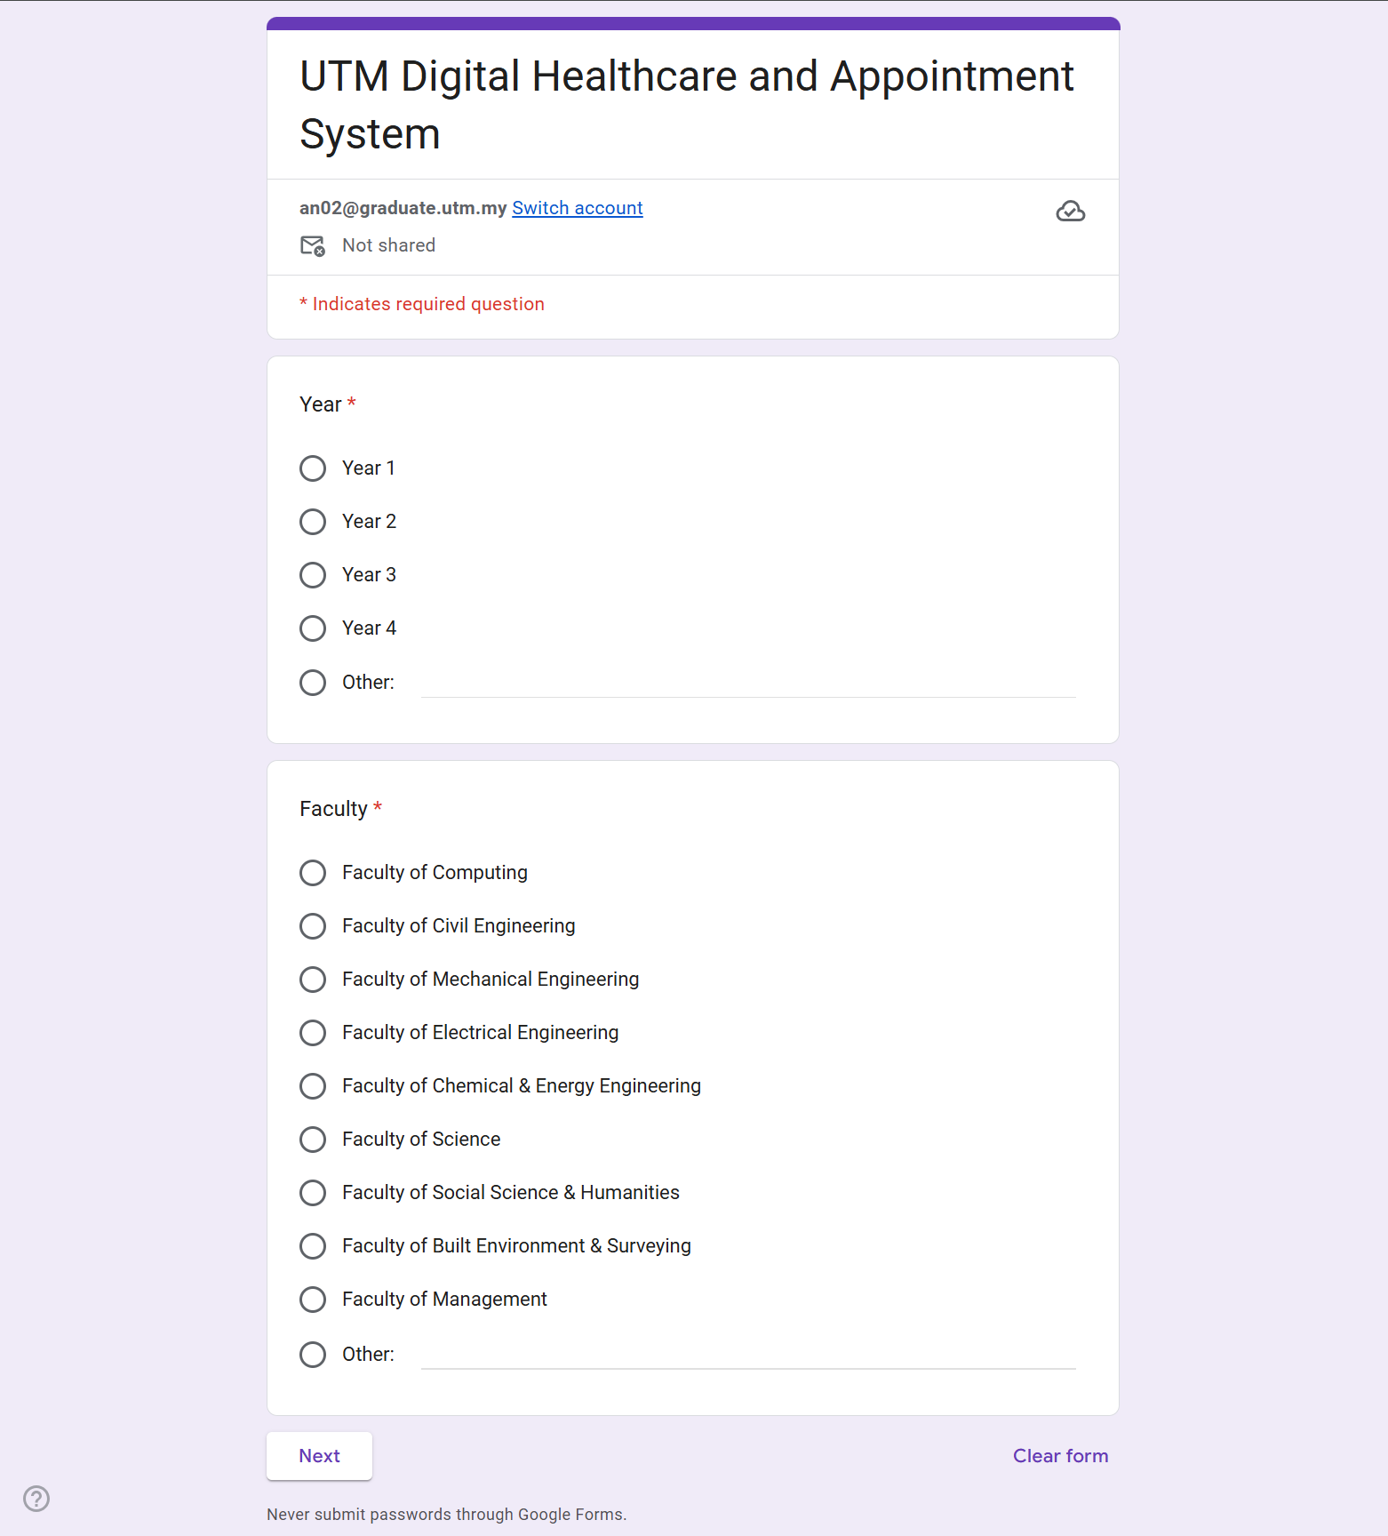
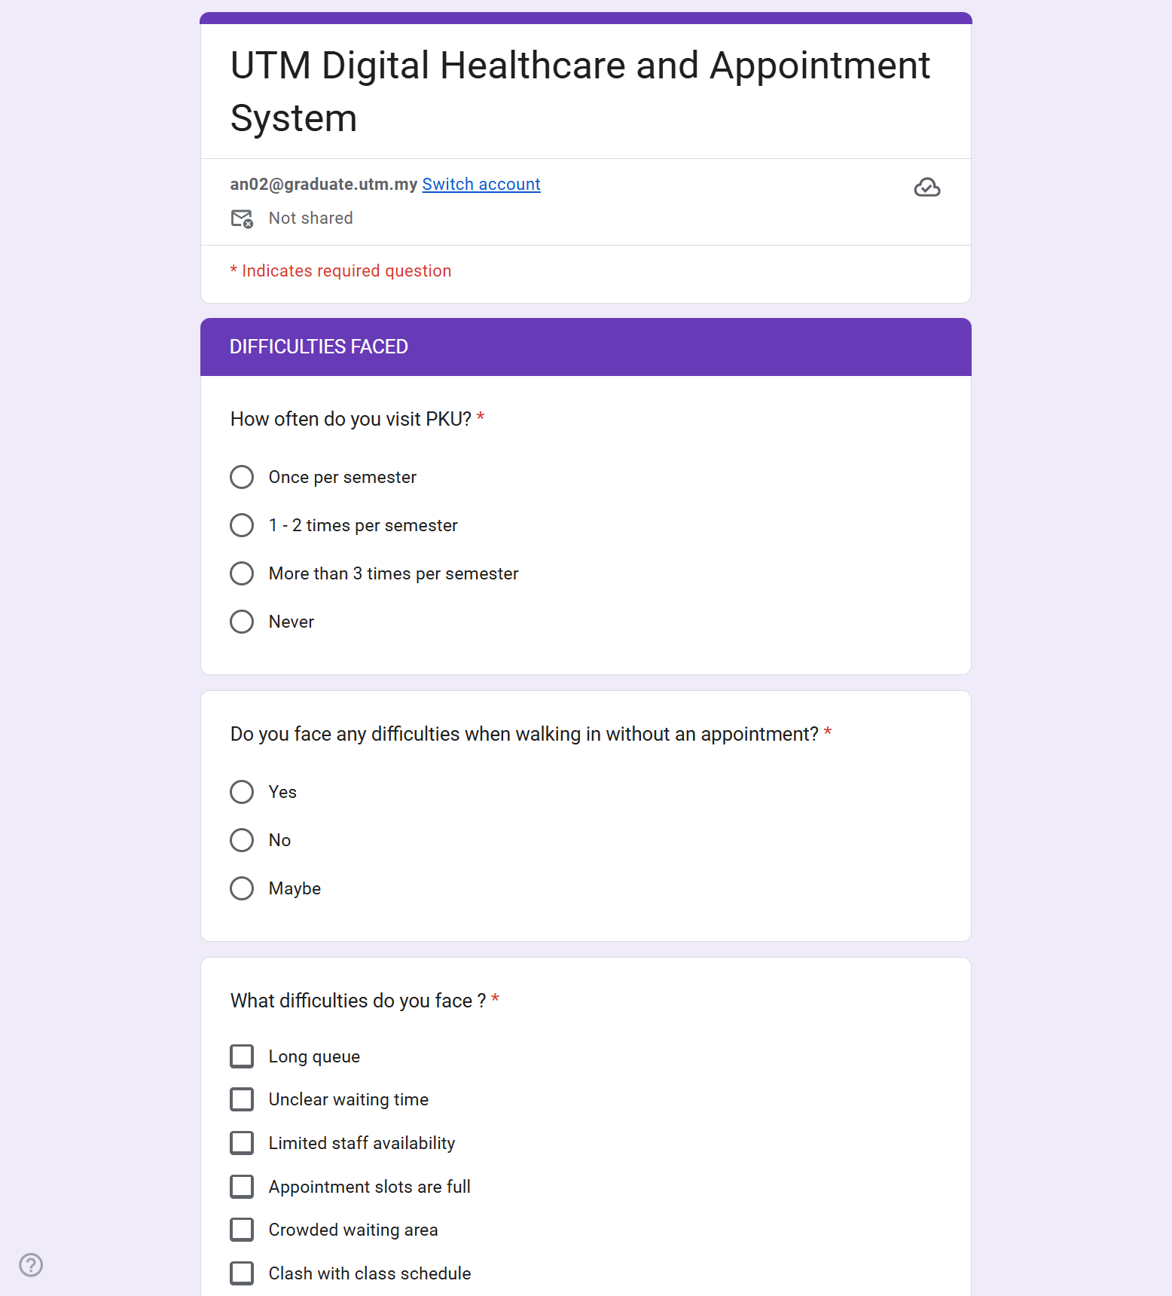
Google Form Survey

Survey Form Link: https://forms.gle/6HtaRj8So69ePqFZ9

2.2 Define Phase
In the define phase, the main challenges were framed into statements which are clear and actionable for designing solutions. Our group reframed the challenge by transforming the perspective of the system into a student-centered perspective. The problem statements our group defined from the empathy phase are as listed below.

- Students have to wait at PKU without any prior planning
- Students cannot see the current queue status when they are not at PKU
- Students unable to communicate with PKU staffs
- Students cannot track their previous visits at PKU

Evidence:
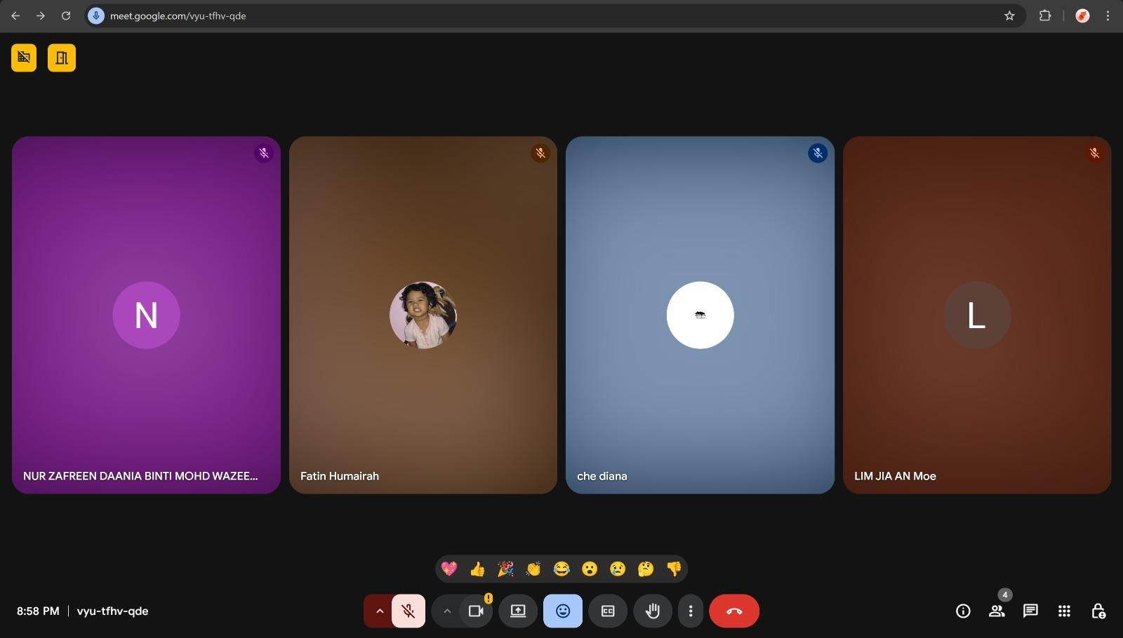
Define Phase Group Meeting on 3rd January 2026

2.3 Ideate Phase
Several ideas were brainstormed during this phase and the most feasible solutions are selected for implementation. Multiple solutions have been explored by our group including appointment booking, queue visualization, centralized dashboard and others which are represented in a mind map.

Evidence:

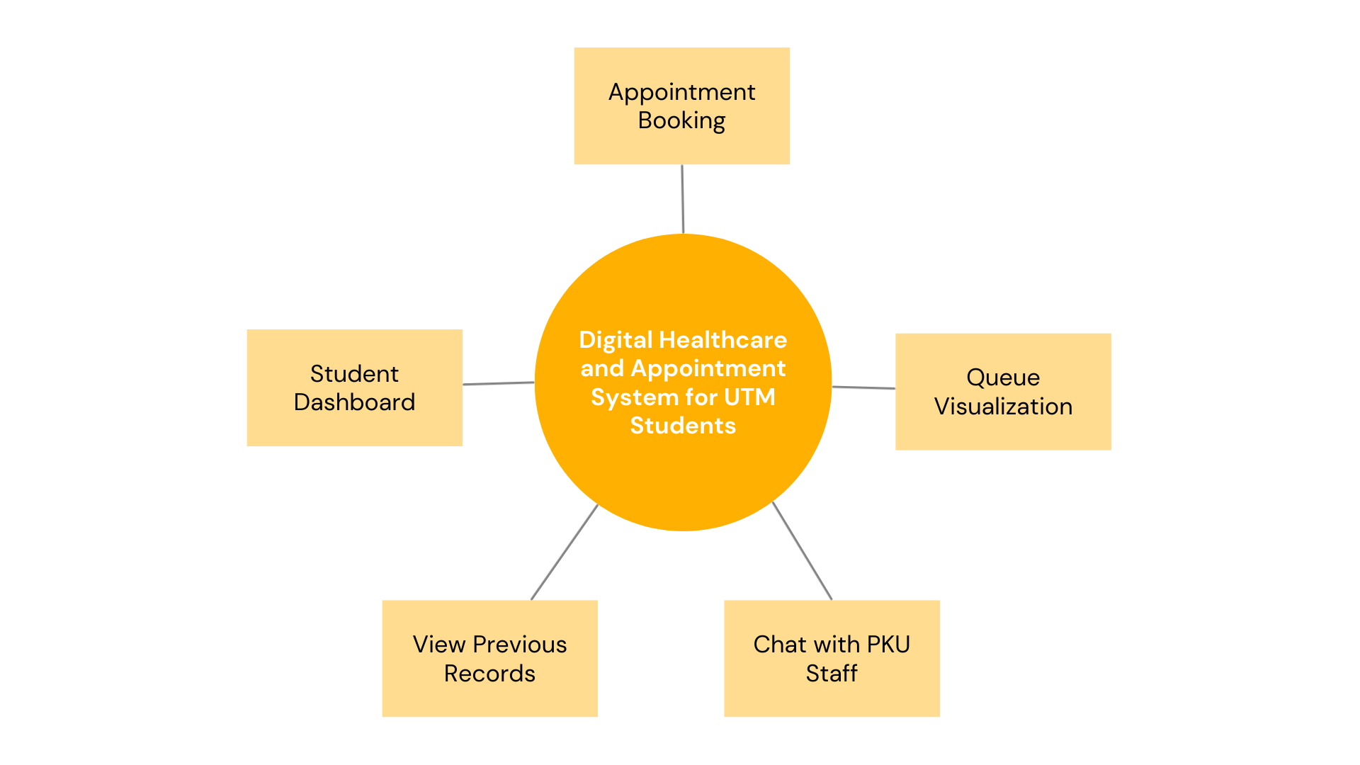

Mind Map of Ideas Brainstorming

2.4 Prototype Phase
By using Figma, our group created a complete interface design for the digital healthcare and appointment system along with full system flow. The prototype is able to illustrate the interaction between the students with the system. Besides, the flow of navigation was designed simply to avoid confusion.

Evidence:
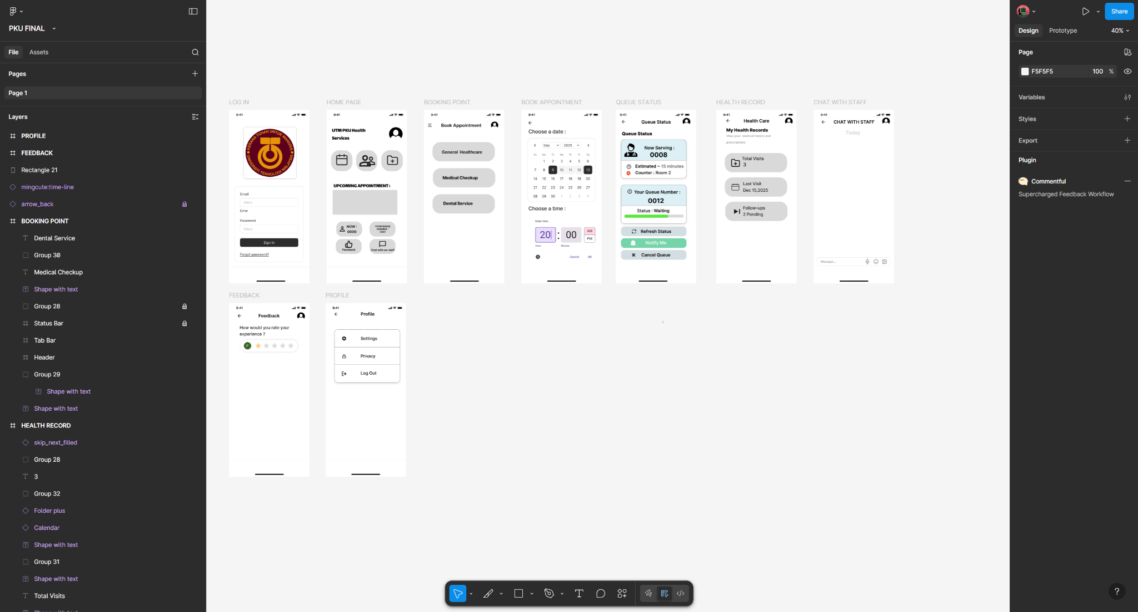
Prototype Development using Figma

2.5 Test Phase
After the prototype was developed successfully, user testing was carried out among our group to simulate the situation of student use. The testing focused on usability, clarity and navigation across all interfaces and modules. The information regarding each testing was recorded.

Evidence:
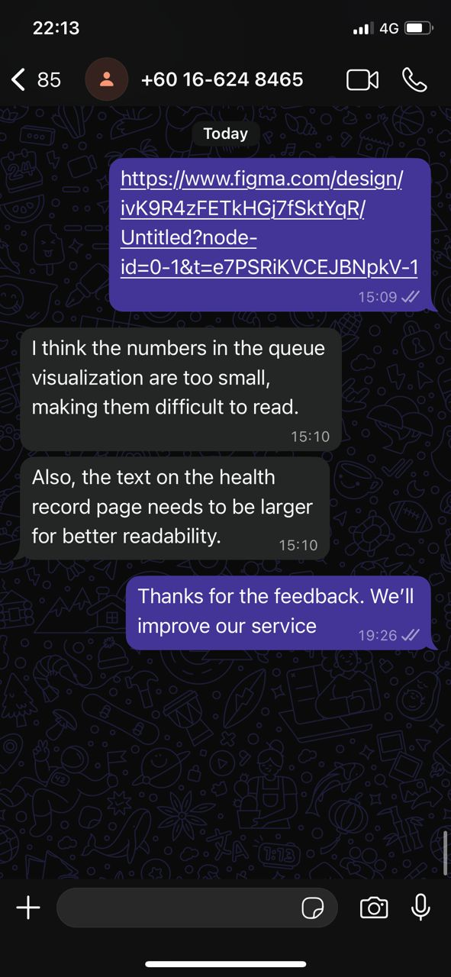
Prototype Testing With User

3.0 Detailed Descriptions: Problem, Solution, and Team Working

3.1 Problem Description
The current situation shows that most UTM students primarily go and access the PKU via direct walk-ins without appointment. The students do not have the ability to check the current status of the queue, predict the time needed for them to wait for their turn and even make a scheduled appointment for healthcare and dental services. Hence, the students may face consequences such as frustration due to long waiting times and stress due to uncertainty regarding when they will be attended by the doctors.

3.2 Proposed Solution
Our proposed solution for these problems is the Digital Healthcare and Appointment System. To enhance the process of accessing healthcare services by UTM students, the system contains several functionalities. The key features of the system include:

- Appointment Booking
The students can make appointments by reserving or booking a time slot for general healthcare or dental services. Hence, unnecessary waiting time can be reduced.
- Queue Visualisation
The system enables the students to check and view the real-time status of the queue at PKU along with estimated waiting time.
- Access to Health Records
By accessing previous records, the students can review back their previous visit, prescriptions given by the doctor and also the follow-up requirements if needed.

Therefore, the implementation of these features ensures convenience, efficiency and reduces waiting times on the queue. Hence, students are empowered in managing their healthcare in a more efficient manner.

3.3 Team Working During Design Thinking
To ensure the system successfully met the requirements, our group has worked cooperatively and closely. Therefore, there are several roles and responsibilities that are introduced among our group, including:
- Project Manager
The project manager is responsible for coordinating the activities involved in completing this project and ensuring that the solution or the system remains student-centered.
- UX Designer
The UX designer designs the frontend components of the prototype, including the student dashboard, appointment booking modules and the real-time queue visualization.
- Research Lead
The research lead is responsible for conducting informal interviews with students to understand their major pain points and their preferences.
- Tester Coordinator
The tester coordinator reviews the prototype created and ensures all the interactions or flows of the interface are functioning correctly by undergoing testing with users.

4.0 Design Thinking Assessment Points

4.1 End of Project Demonstration
An assessment is carried out at the final stage of the project by demonstrating the final prototype of the system. The usability, clarity and effectiveness of the Digital Healthcare and Appointment System are evaluated by presenting the complete frontend or interface of the system to the users. Therefore, feedback on each feature such as visualization of the queue, flow of making appointments and ease of navigation through the system can be gathered and collected. Hence, this assessment can analyze whether the system successfully solves the problems or challenges faced by the students thoroughly.

4.2 Transition Between Phases
In addition, assessment is also conducted between each transition of design thinking phases. Before moving towards the problem definition in the define phase, the findings obtained from the empathy phase are reviewed detailedly to ensure the user requirements are understood comprehensively. To ensure the defined problem statements are both user-centered and actionable, an evaluation is carried out during the transition from the define phase to the ideate phase. Apart from that, the corresponding ideas generated during the ideate phase are also assessed regarding their feasibility before moving on to the prototype phase. Evaluation on the identified requirements is carried out once the prototype is developed and transitioned to the test phase. The areas of improvement are identified based on the feedback collected from user testing. Hence, a structured workflow can be maintained while ensuring each phase is accomplished effectively.

5.0 Design Thinking Evidence

5.1 Sample Work by Students
Several works have been done by our group to accomplish this project of designing the Digital Healthcare and Appointment System for UTM Students. The sample works are listed below.
- A survey conducted among UTM students
- A mind map of brainstorming ideas for the functionalities of the system
- A prototype developed by Figma which consist a complete set of system interfaces
- Several user testing logs

5.2 Record for Each Phase

5.2.1 Empathy Phase
The student’s pain points when they are using PKU healthcare services are understood.
Survey Questions:
- How often do you visit PKU?
- Do you face any difficulties when walking in without an appointment?
- Are your lecture schedule or study time affected by the long queue?
- Do you think an online appointment system will be beneficial?

Answers:
- Once per semester
- Yes (long queue, unclear waiting time, crowded waiting area, clash with class schedule)
- Often, sometimes
- Yes

Data Collected:
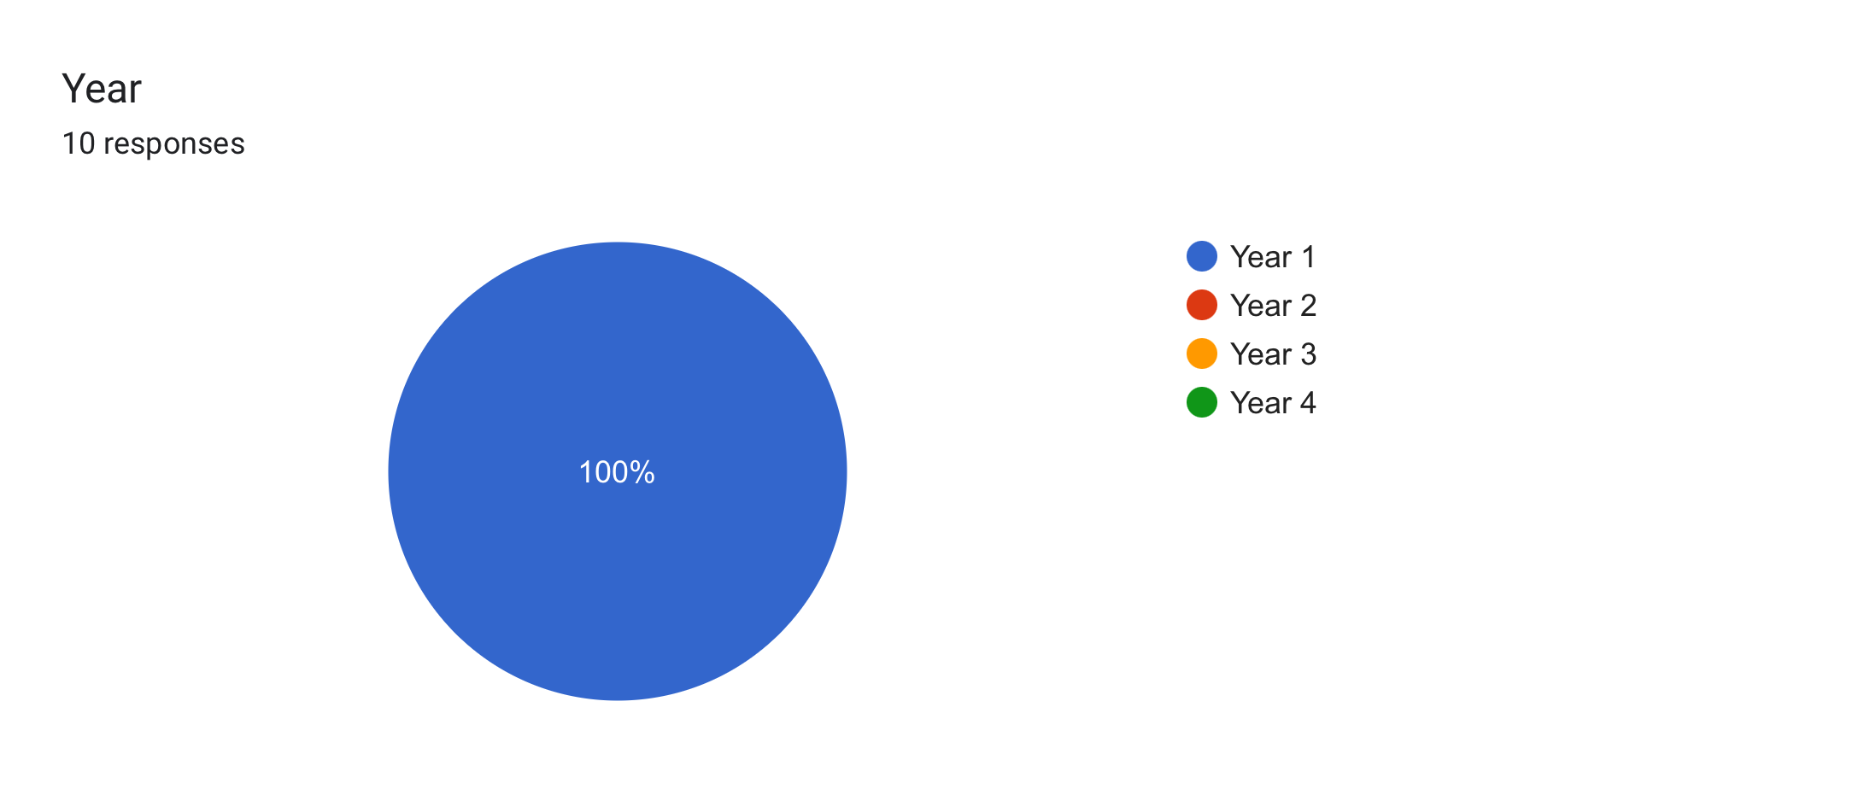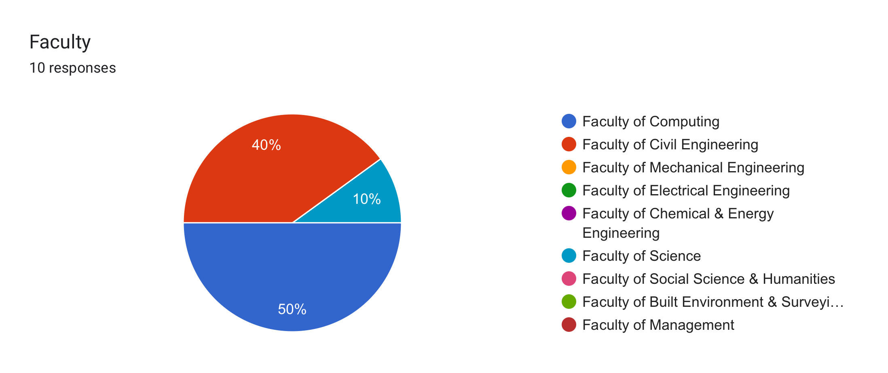
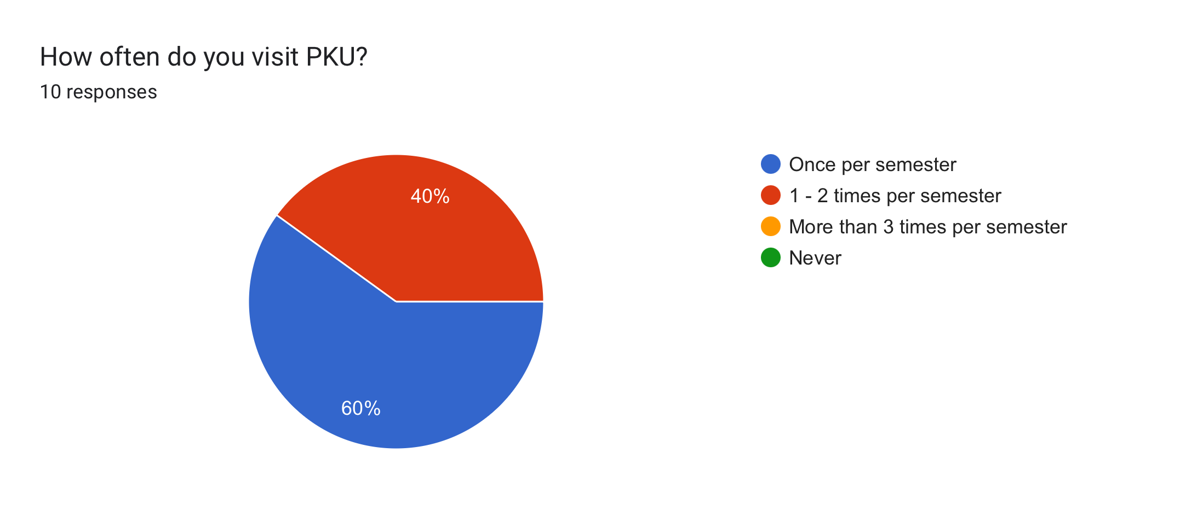
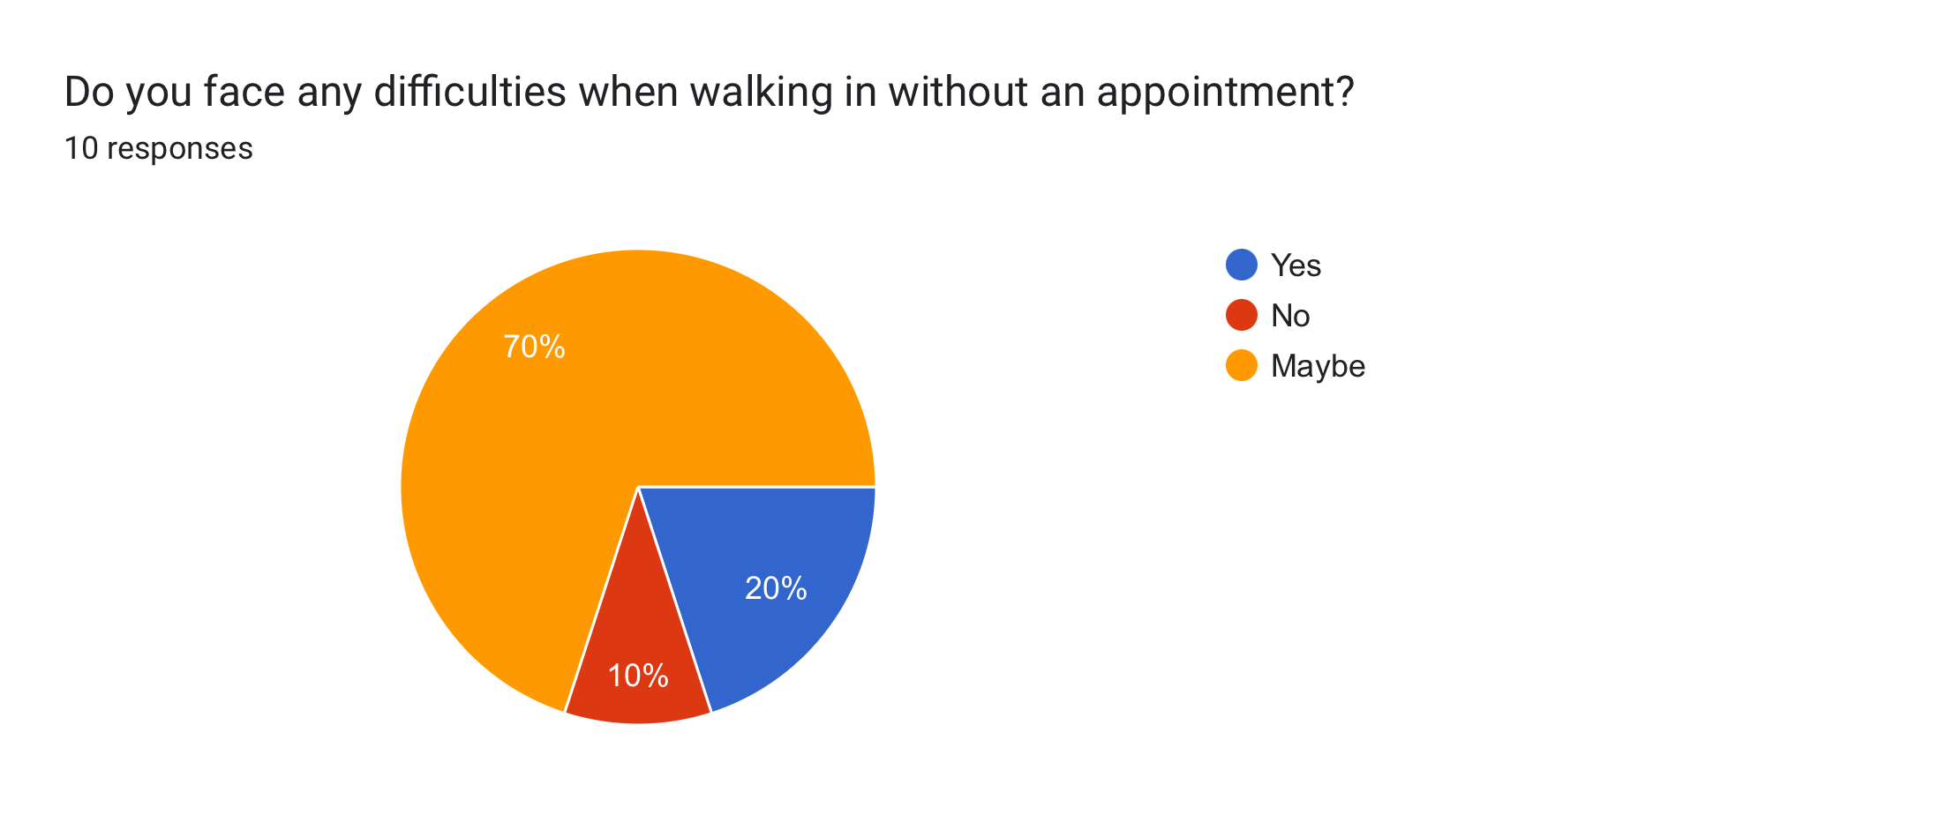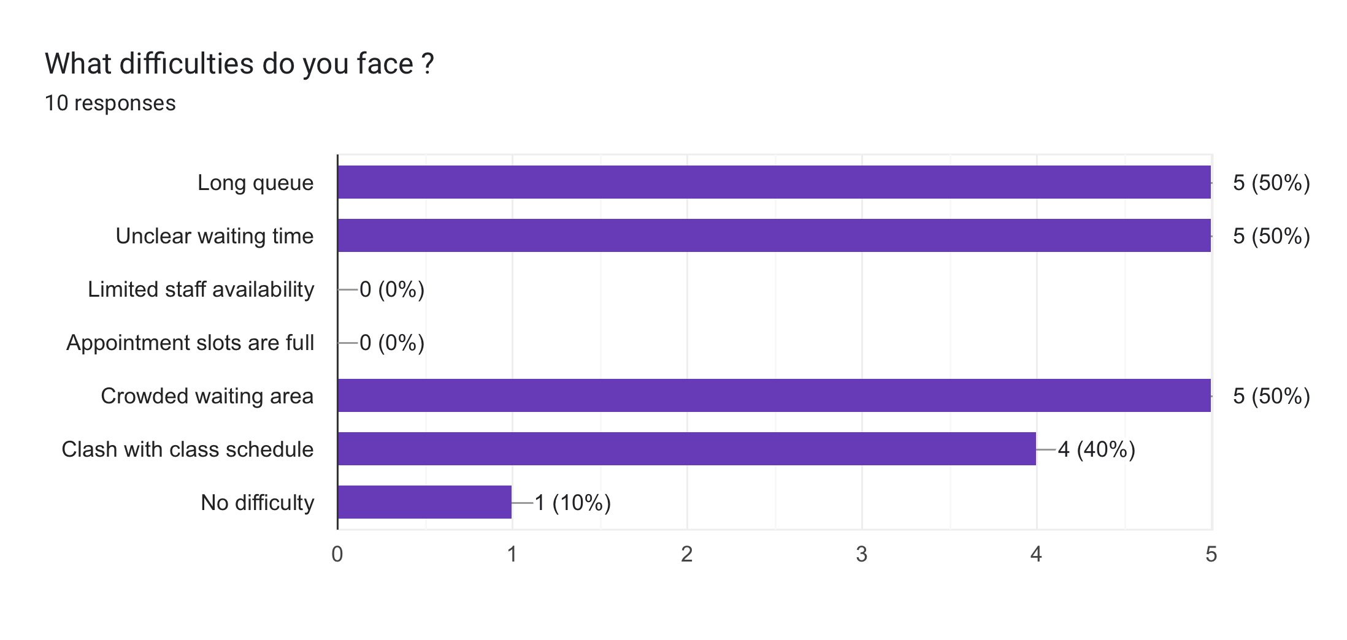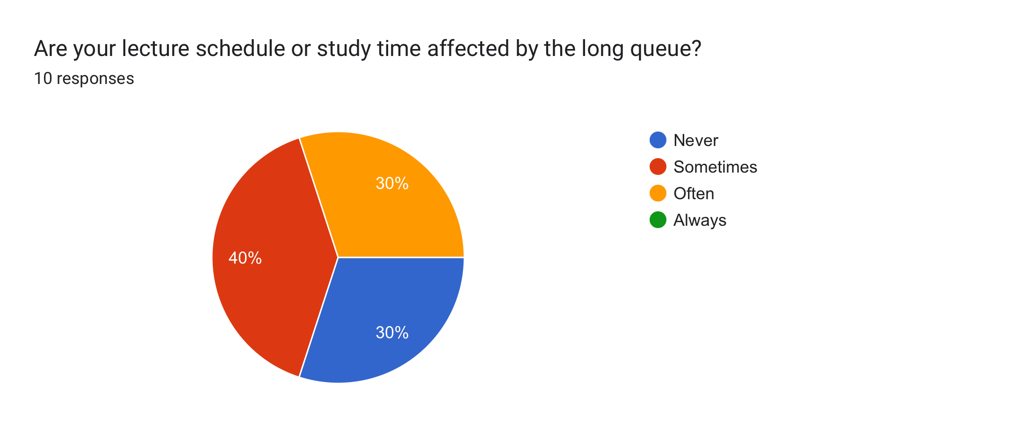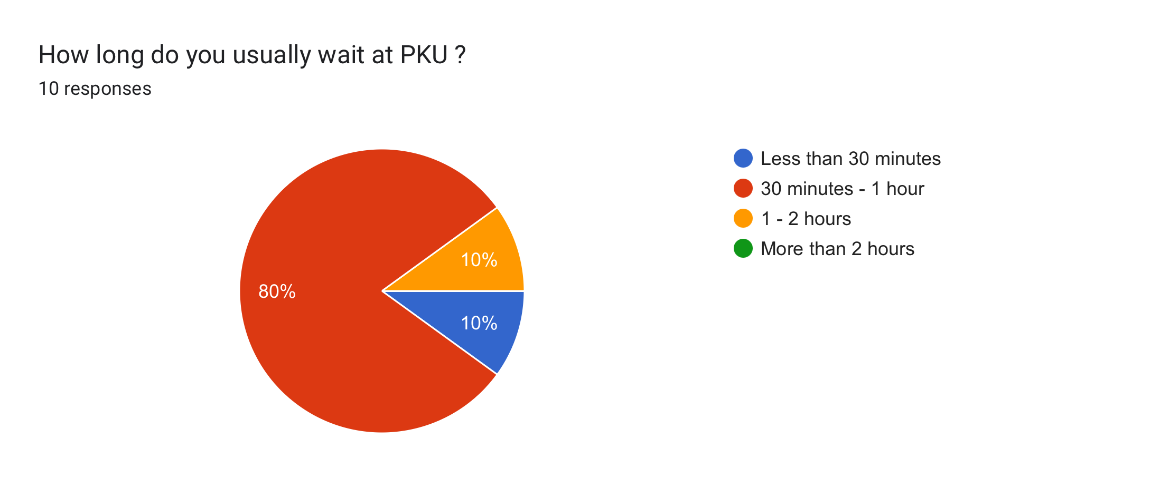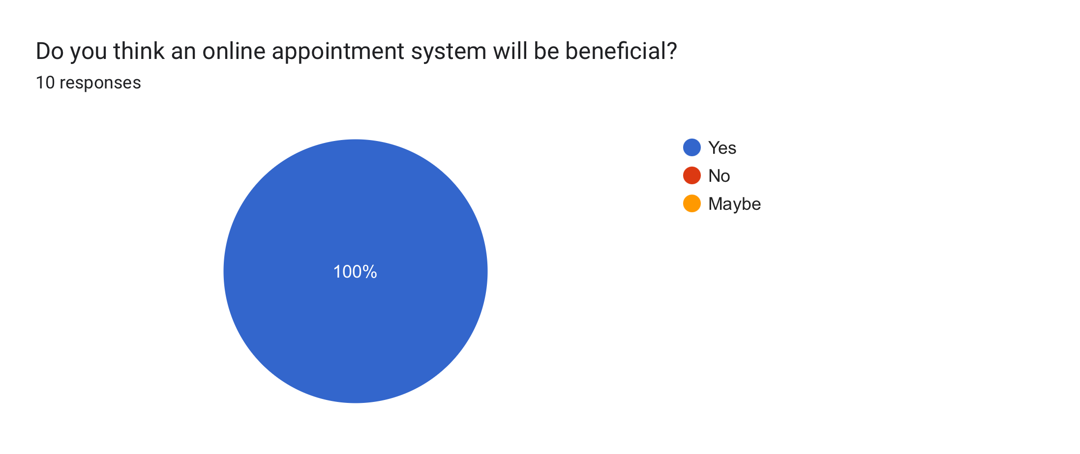
Survey among UTM Students

Composite Character:
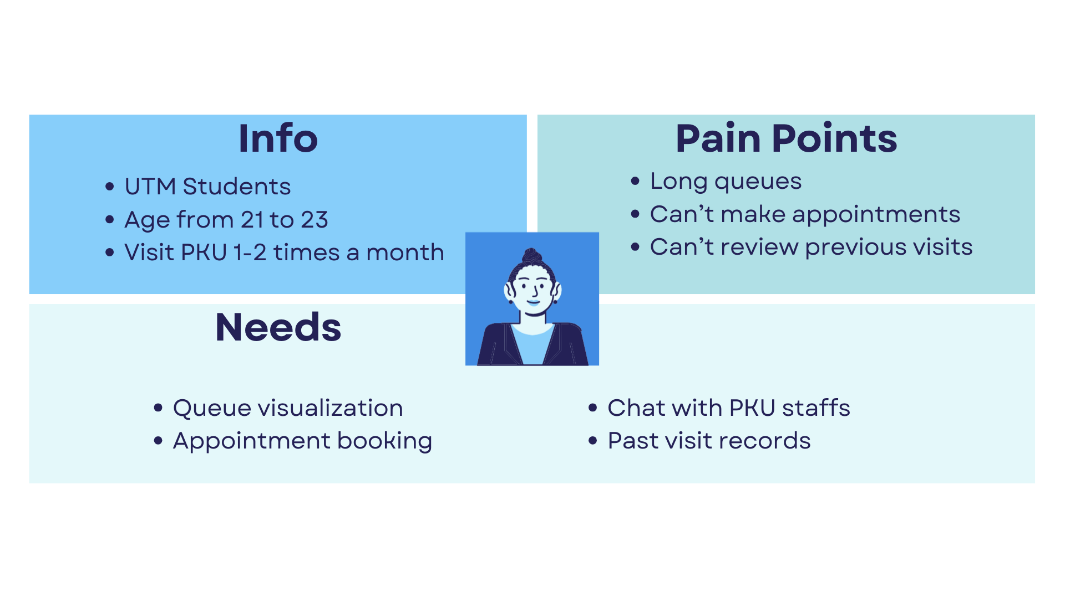
Composite Character: UTM Students

5.2.2 Define Phase
The needs of students are converted into problem statements that are actionable.
Table of Problem Statements
Problem | Needs
Students have to wait at PKU without any prior planning | Real-time queue visualization
Students cannot see the current queue status when they are not at PKU | Appointment booking feature
Students unable to communicate with PKU staffs | Chat function with PKU staffs
Students cannot track their previous visits at PKU | Records of previous visits at PKU

5.2.3 Ideate Phase
The ideas brainstorming process is carried out among group members in our Whatsapp group where each member provides their ideas based on the outcome obtained from the define phase.

Team Discussion Screenshot:
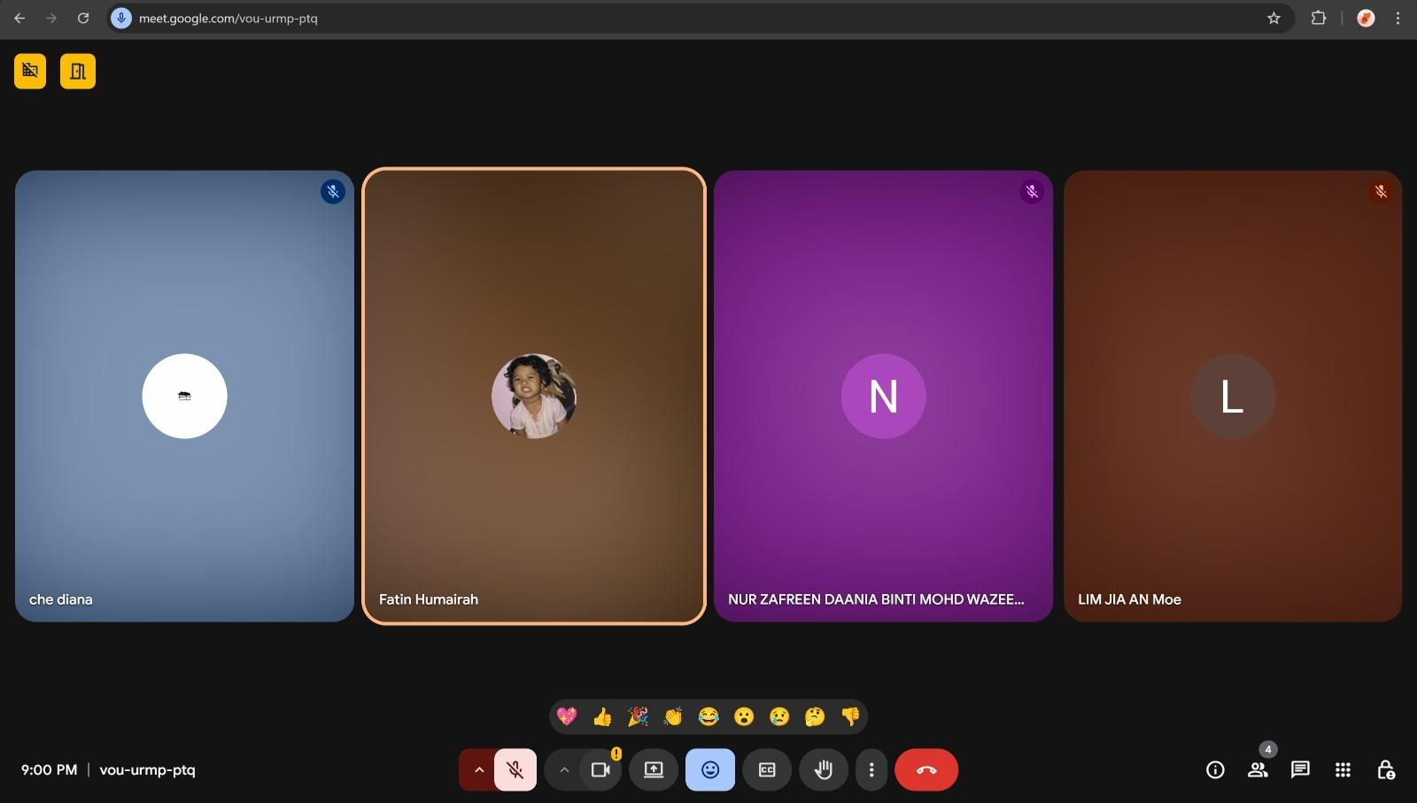
Ideate Phase Group Meeting on 6th January 2026

5.2.4 Prototype Phase
A low fidelity prototype is created by using Figma to visualize the flows and usability of the system.

Interfaces of Digital Healthcare And Appointment System For Utm Students Designed using Figma
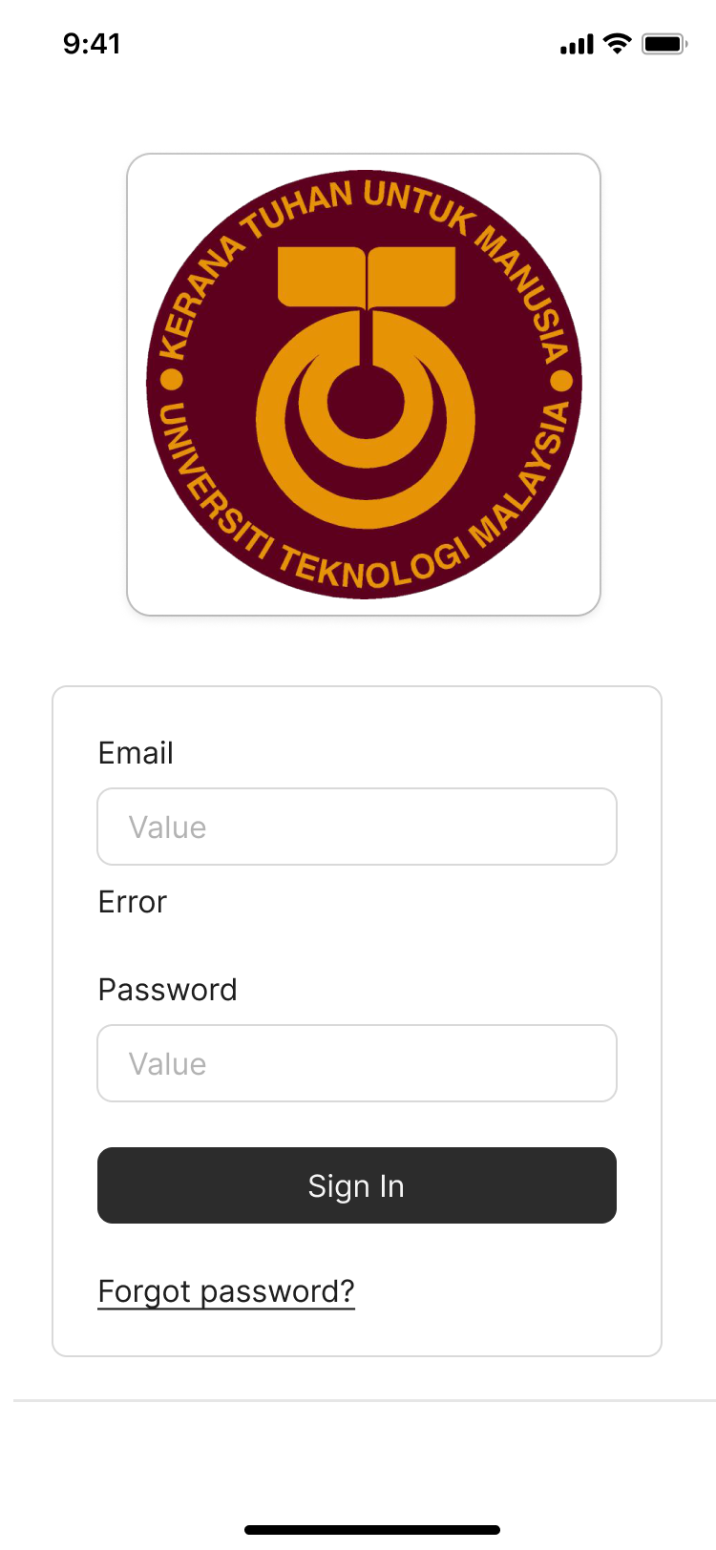 | 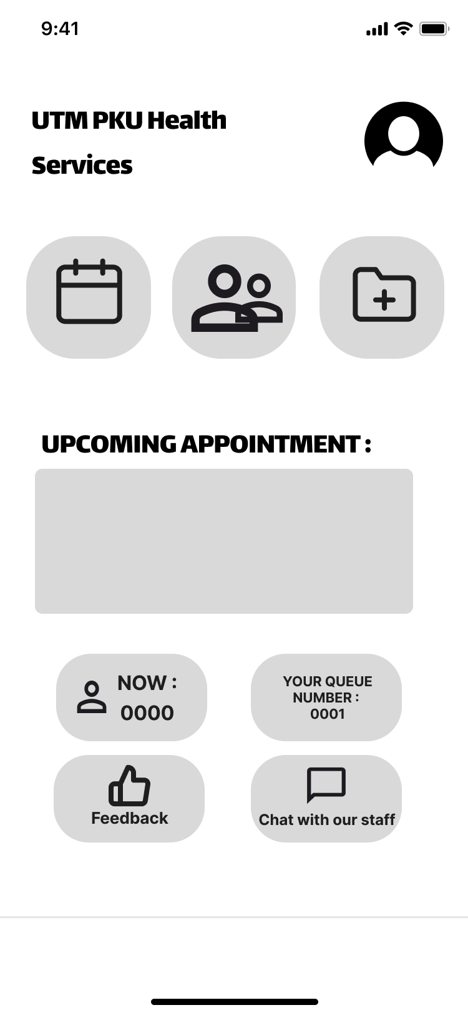 | 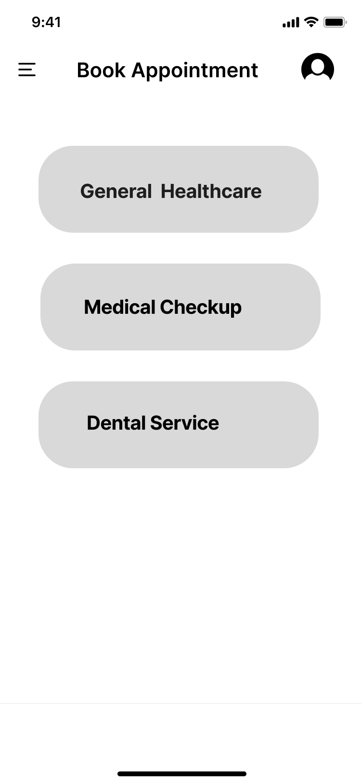
Login Page | Dashboard Page | Booking Page

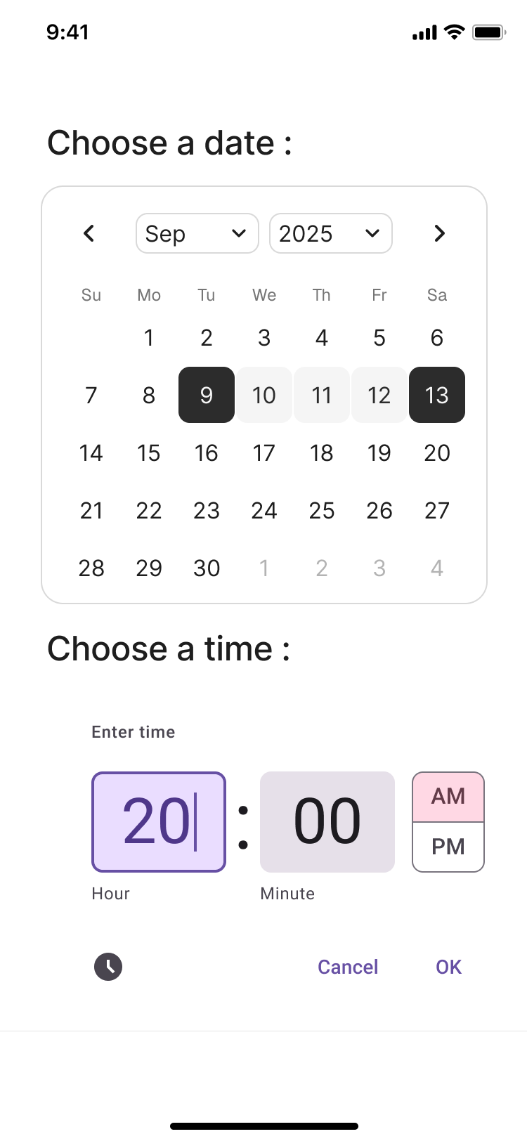 | 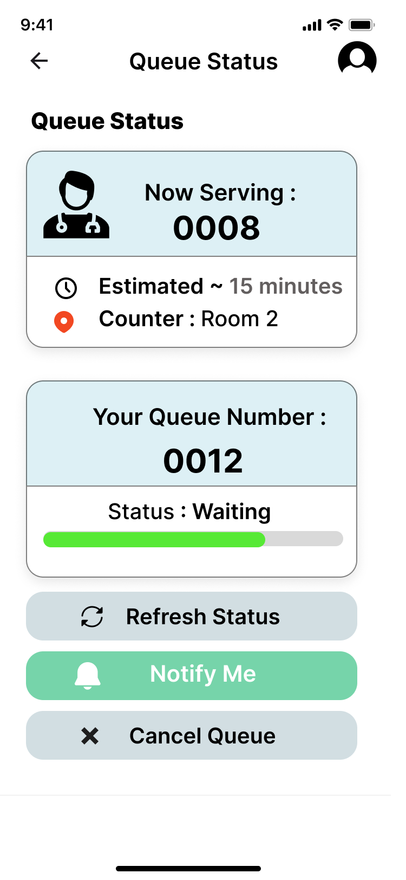 | 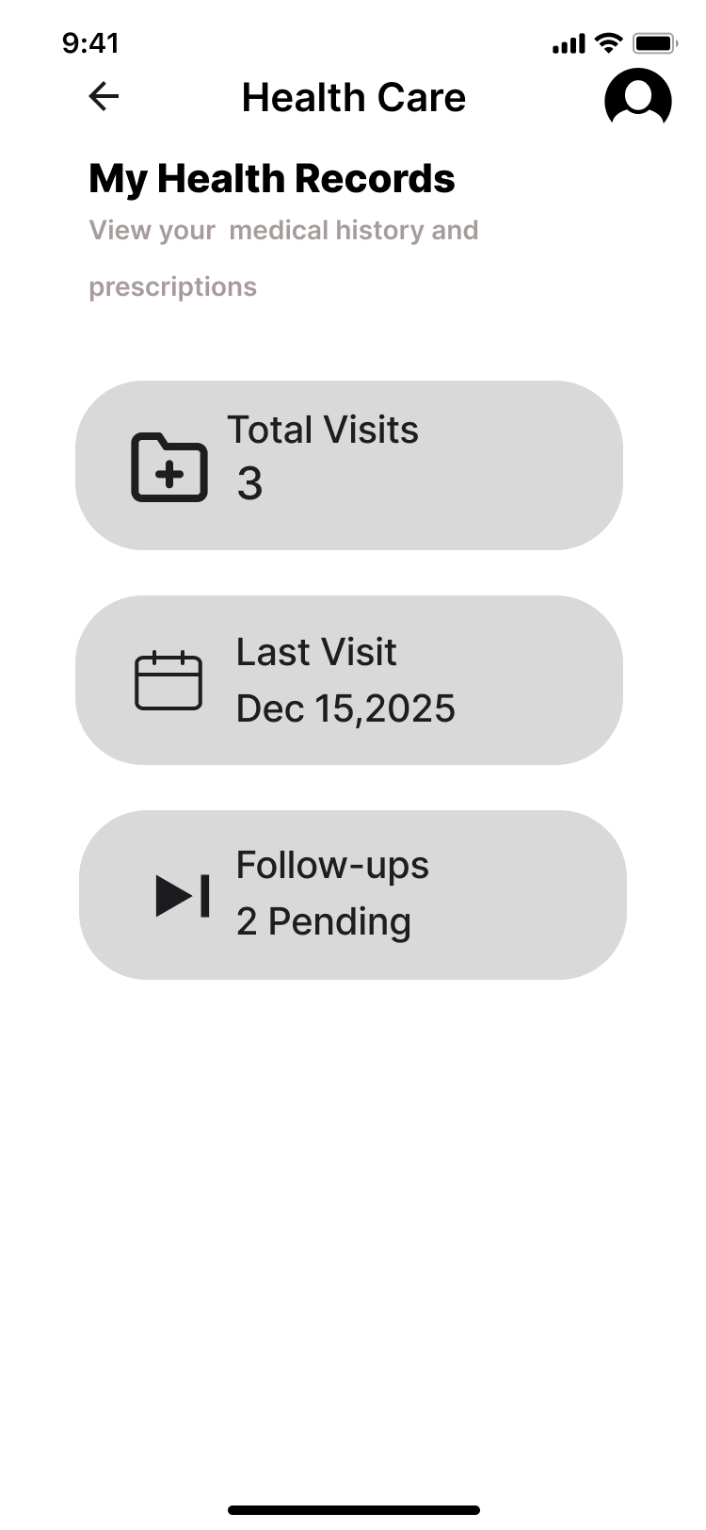
Book Appointment Page | Queue Status Page | Health Record Page

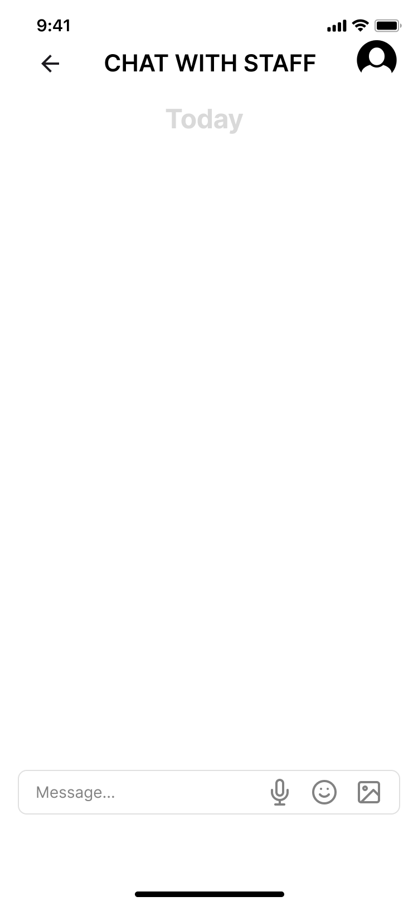 | 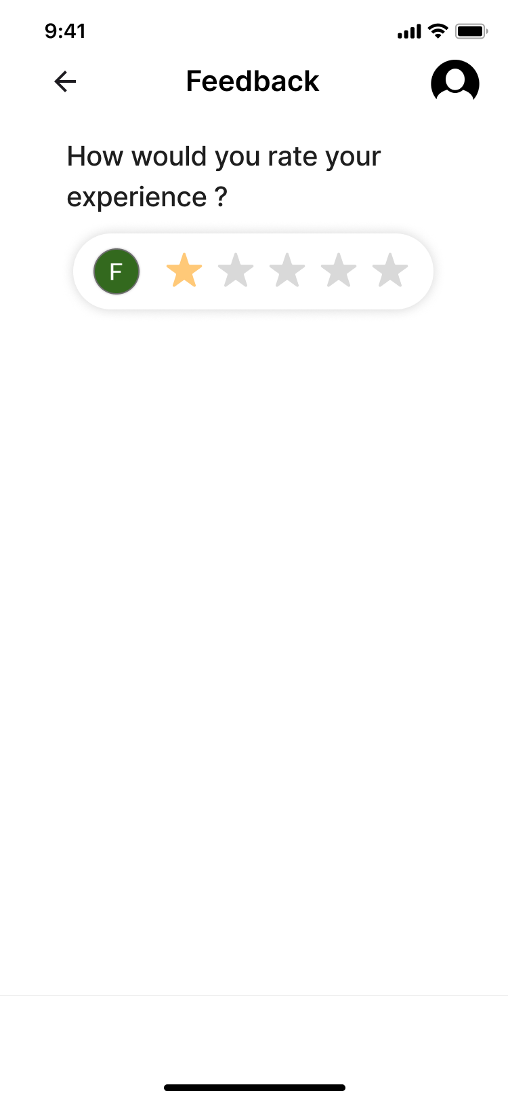 | 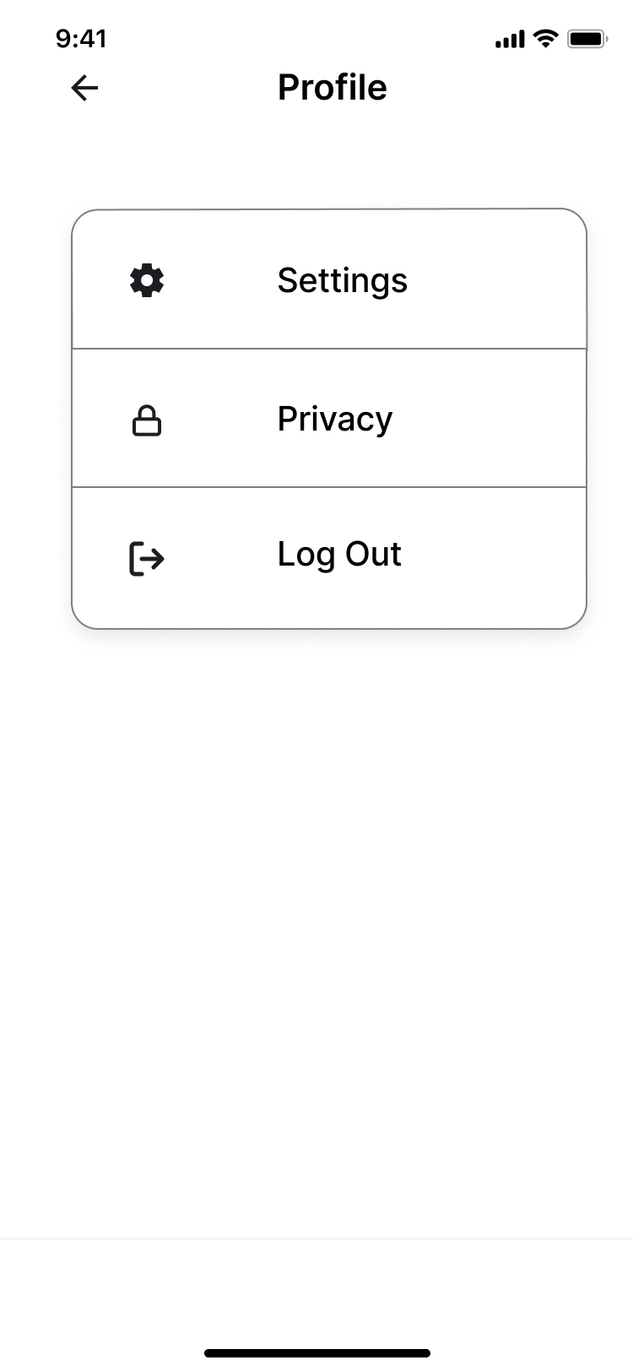
Chat with Staff Page | Feedback Page | Profile Page

5.2.5 Test Phase
The prototype is sent to the user who has conducted the informal interview with our group member. The issues identified by the user are recorded and appropriate resolutions have been carried out on the prototype.

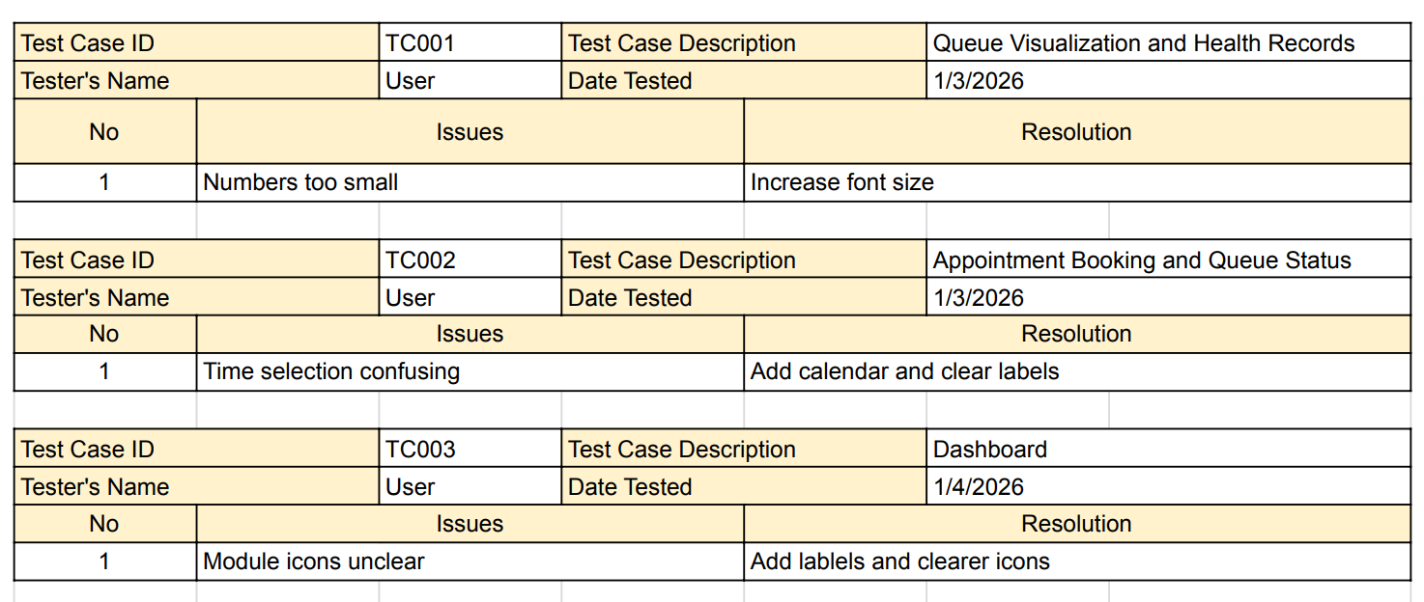
Prototype Testing Logs

6.0 Reflections

6.1 Member 1: Lim Jia An
- As a computer science student who specializes in computer networks and security, my goal is to specialize in cloud computing and cybersecurity, and work in MNCs like IBM, AWS and Google to develop and provide systems that are impactful to the users.
- Throughout this project, I have learned that understanding user needs is important in designing intuitive and reliable systems or applications. Therefore, I learned that usability should also be focused by security or cloud-based applications to be effective.
- I will apply user-centered design in my future projects regarding cloud or security. Besides, I will also improve my skills on UI/UX and prototyping to design more interfaces that are secure and user-friendly.

6.1 Member 2: Fatin Humairah Binti Norhisham
- As a computer networks and security student my goal is to understand networking basics like to learn how computers , servers and devices connect and communicate. Next is to develop practical skills like setting up secure networks in labs or simulators. Lastly, prepare for real-world roles like get ready for jobs like Network Engineer, Security Analyst, Penetration Tester or System Administrator.
- I learned that effective system design requires balancing usability with security , scalability and reliability.
- I learned that growing in the IT industry means balancing technical skills with usability, security and adaptability, while continuously learning and building practical projects.

6.2 Member 3: Nur Zafreen Daania Binti Mohd Wazeer
- My goal is to master and be knowledgeable in basic computer literature and infrastructure as a computer science student enrolling in Technology Information System course. I aim to apply theoretical knowledge I have gained from this course into practical skills that will be beneficial when stepping into the industry.
- This design thinking has familiarised me with systematic and logical thinking that is applied and useful in practical settings. I am also exposed to basic structured procedures of a project, which definitely brings me a step forward to my goals.
- To improve my potential in the industry, I will constantly upskill myself in the IT industry and keep up to date with current and ever-evolving technology trends.

6.3 Member 4: Che Nurdiana Farahana Binti Che Rezali
- My goal as a computer networks and security student is to develop strong technical skills in designing and securing IT systems. I aim to build practical expertise to address real-world security challenges in the IT industry.
- Learning and applying design thinking helps me approach problems systematically and creatively. It enables me to identify problems clearly and develop user-centered solutions, which are essential in cybersecurity and networking.
- To develop my potential in the IT industry, I will work on hands-on projects, collaborate with peers, and build on my experience in testing and presentation preparation, which will help me gain practical skills and confidence needed for future IT roles.

7.0 Task for Each Member
Member | Task
Lim Jia An | Project coordination and report writing
Fatin Humairah Binti Norhisham | UX design and prototyping
Nur Zafreen Daania Binti Mohd Wazeer | Research and empathy study
Che Nurdiana Farahana Binti Che Rezali | Testing and presentation preparation

